Cellular automata explorer
Developer Guide

install
Clone the following repos into the same folder – this will create 2 sub folders CA and jsinc
- GitHub - open768/CA: cellular automata machine for javascript
- GitHub - open768/jsinc: common javascript functions
Dependent libraries are referenced from CDN

User interface
A Jquery UI interface composed of widgets - Widgets use events to communicate, which are implemented using bean.js
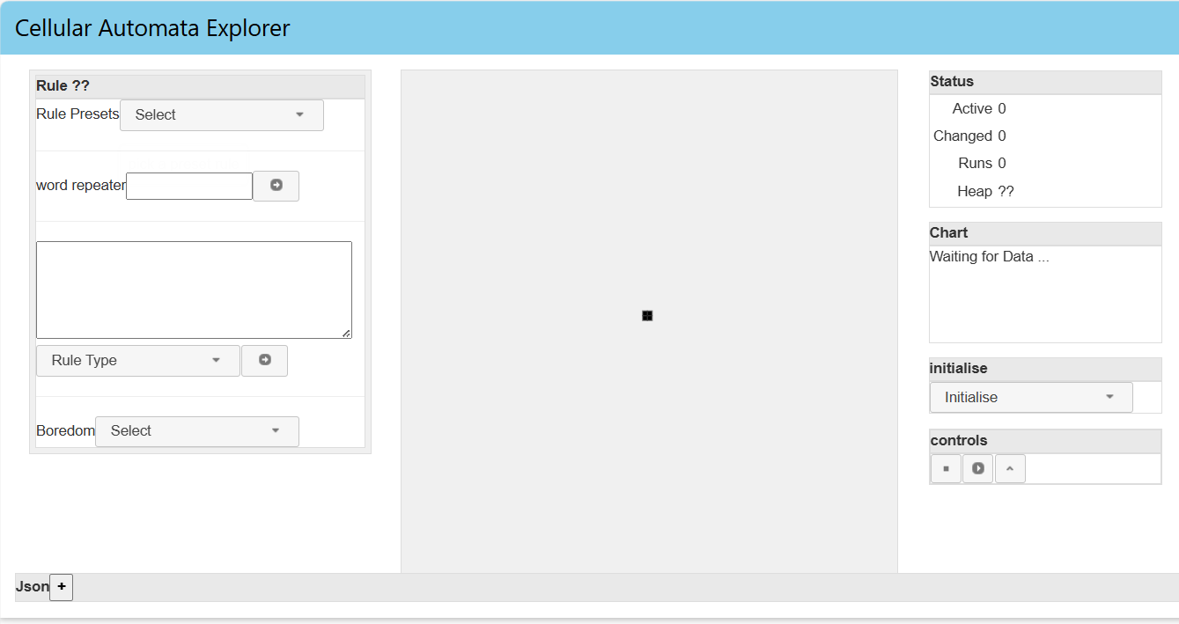
Index.html
js/widgets/index/caindex.js
…/cacontrolsl.js
js/components/cacanvas.js

…/cacontrolsr.js
..components/ castatus.js
..components/ cachart.js
..components/ cagridinit.js
..components/ caremotecontrol.js

UI components
Component | Description
Caindex | The main UI for the index page this contains cacontrolsl, cacanvas, cacontrolr
➡️ cacontrolsl | Left-hand side controls – mainly rule definition related UI
➡️ cacanvas | The CA visualiser (contains a cagrid)
➡️ cacontrolsr | right-hand side controls – mainly UI related to running the CA
➡️➡️ castatus | Shows statistics
➡️➡️ cachart | Shows a timeline graph of alive and dead cells
➡️➡️cagridinit | Initialises cagrid with preset patterns
➡️➡️caremotecontrols | Stop and start running of rules

events
The widgets use caEvents to communicate. implemented by bean.js
- subscribe to events using cCAEventHelper.subscribe_to_... methods
  - subscribers listen for the class of events – actions are picked from the event
- trigger events using the appropriate event class eg
oEvent = new cCAActionEvent(grid_name, cCAActionEvent.actions.control, actionID)
oEvent.trigger()

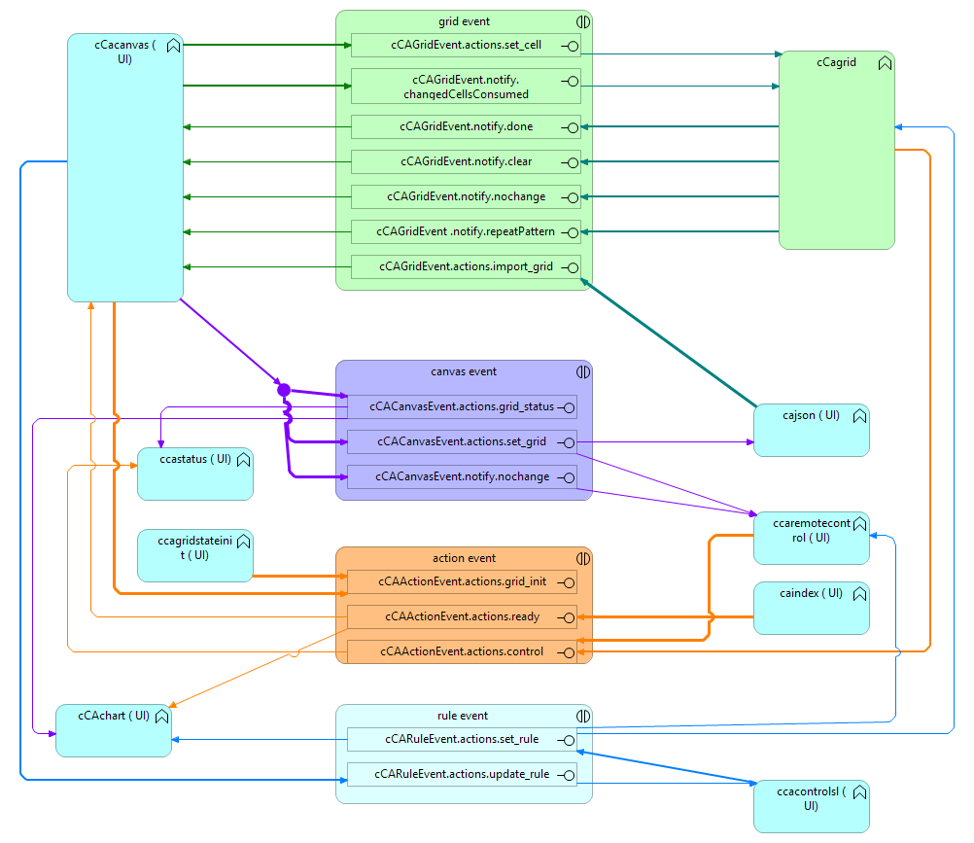

GRID Events

subscribed
Component | action | description
ccagrid | cCAGridEvent.notify.changedCellsConsumed  cCAGridEvent.actions.set_cell
cabanas | cCAGridEvent.notify.done  cCAGridEvent.notify.clear  cCAGridEvent.notify.nochange  cCAGridEvent .notify.repeatPattern  cCAGridEvent.actions.import_grid

triggers
Component | action | description
cagrid | cCAGridEvent.notify.clear  cCAGridEvent.notify.nochange  cCAGridEvent.notify.done  cCAGridEvent.notify.repeatPattern
Ccacanvas | cCAGridEvent.notify.changedCellsConsumed  cCAGridEvent.actions.set_cell
caJson | cCAGridEvent.actions.import_grid:

Canvas Events

subscribed
cCaChart | cCACanvasEvent.actions.grid_status
cCAJson | cCACanvasEvent.actions.set_grid
cCARemotecontrol | cCACanvasEvent.actions.set_grid  cCACanvasEvent.notify.nochange
cCaStatus | cCACanvasEvent.actions.grid_status

triggers
Component | action | description
ccacanvas | cCACanvasEvent.notify.nochange  cCACanvasEvent.actions.grid_status  cCACanvasEvent.actions.set_grid

Action events

subscribed
ccagrid | cCAActionEvent.actions.grid_init  cCAActionEvent.actions.control
ccacanvas | cCAActionEvent.actions.ready
cCaChart | cCAActionEvent.actions.grid_init
cCaStatus | cCAActionEvent.actions.control | cCAGridTypes.actions.play  cCAGridTypes.actions.stop  Starts and stops heap watching

triggers
Component | action | description
ccagrid | cCAActionEvent.actions.control | cCAGridTypes.actions.step
ccanvas | cCAActionEvent.actions.grid_init | Initialises to a block
ccagridstateinit | cCAActionEvent.actions.grid_init | Initialises to selected pattern ID from pulldown
ccaremotecontrol | cCAActionEvent.actions.control | Start and stop
caindex | cCAActionEvent.actions.ready | informs subscribers that UI is ready

Rule events

subscribed
Ccagrid | cCARuleEvent.actions.set_rule | Sets the rule
Ccachart | cCARuleEvent.actions.set_rule | Clears the chart when rule is set
ccaremotecontrol | cCARuleEvent.actions.set_rule | Enables buttons after rule is set
ccacontrolsl | cCARuleEvent.actions.update_rule | Updates the text box

triggers
Component | action | description
ccacanvas | cCARuleEvent.actions.update_rule | Update rule on successful import
Ccacontolsl | cCARuleEvent.actions.set_rule | Sets the rule after UI clicks

CaCanvas Component
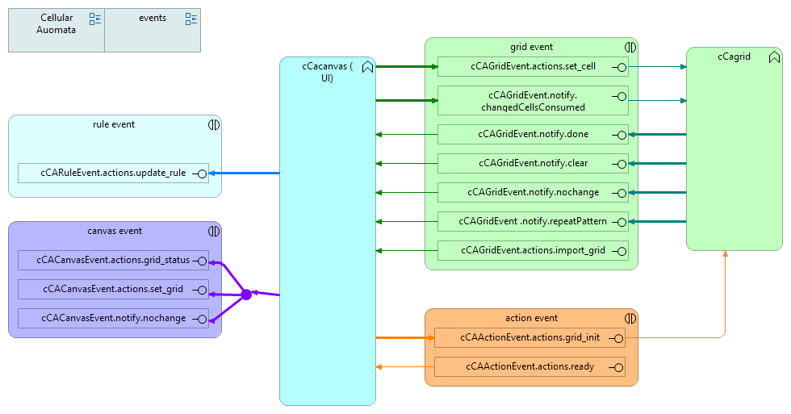 This component is wrapped in a jQuery UI widget. It is responsible for drawing the CA (running in a grid) and interacting with the CA.
A CAgrid is added to the component , which represents the CA state machine
- after it has received the event cCAActionEvent.actions.ready
- and also after receiving the event cCAGridEvent.actions.import_grid

